Structure of the Brain

Directions: Label the Parts to the diagram below.
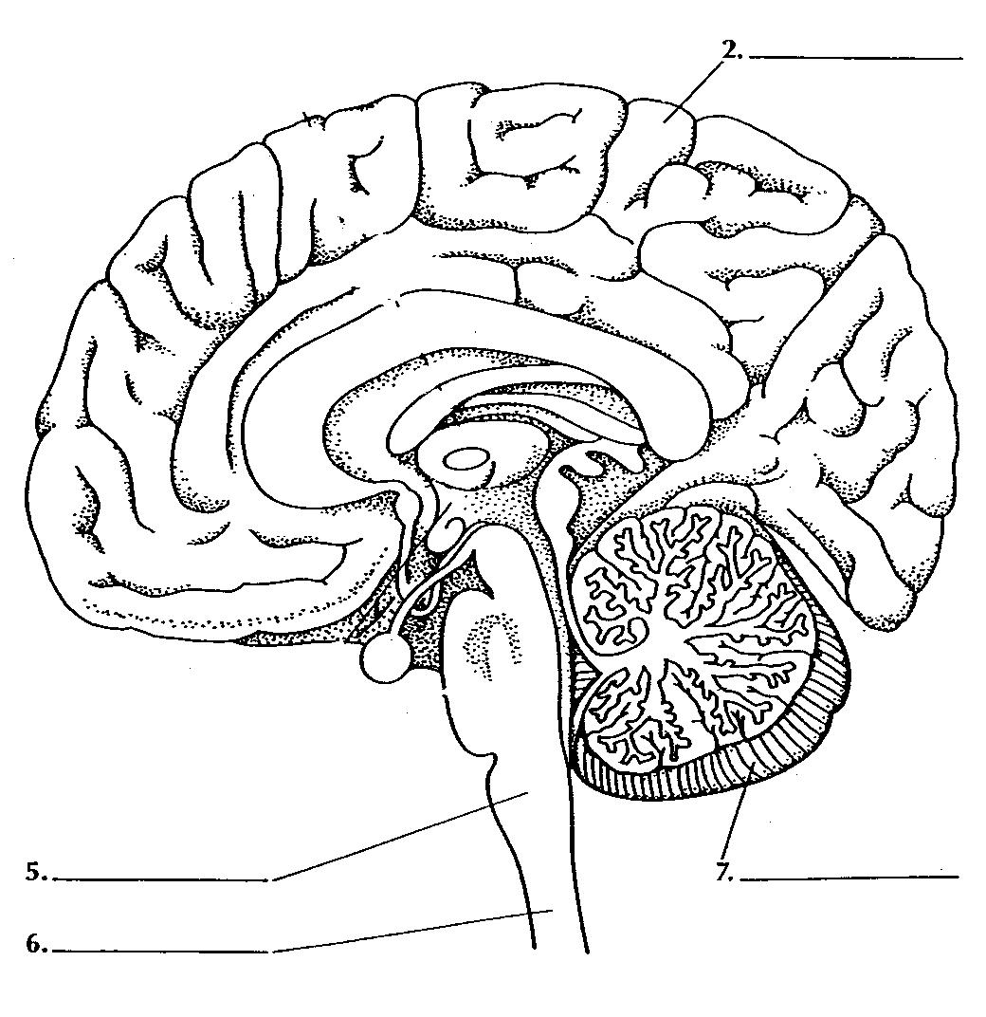

Lobes of the Cerebrum

Label the following four major lobes of each hemisphere of the cerebrum: 1.frontal, 2. Parietal, 3. Occipital and 4. Temporal lobe. Then, fill in the blanks below with the correct answers.

1/ The _________________ lobes control some body movements, reasoning, judgment and emotions.
The sense of vision is located in the _____________lobe.
The sense of hearing is interpreted in the _________________ lobes.
The _______________ lobes interpret sensations such as pain, pressure, touch, hot and cold.

Nervous System Structure

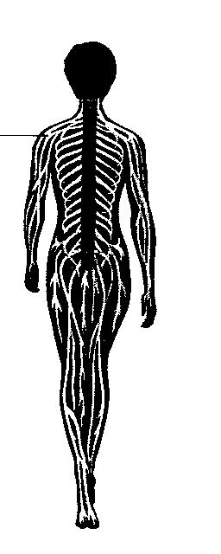
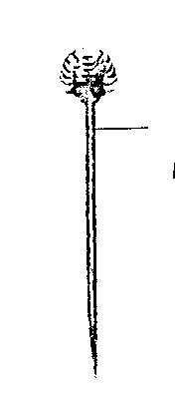

Central
Nervous
System
(CNS)
Brain, spinal cord
Peripheral
Nervous System
(PNS)

Autonomic Nervous System
(involuntary)
Relays information to internal organs.
Somatic Nervous System
(voluntary)
Relays information to and from skin and skeletal muscles.

Sympathetic Nervous System

Controls organs in times of stress
Parasympathetic Nervous
System

Controls organs when body is at rest.

2. What is the control center of the entire nervous system?

3. Which part of the CNS is made up of the midbrain, pons, and medulla oblongata?

4. Which part of the nervous system carries impulses between the body and the central nervous system?

5. List three kinds of neurons that would be involved in a reflex impulse.

6. Which part of the brain sends impulses to the autonomic nervous system during life-threatening emergencies?

7. Compare the parasympathetic nervous system with the sympathetic nervous system.

8. Trace the pathway of impulses through the nervous system in response to feeling rain on your skin.

Read the paragraphs in the below and look at the diagram. Then answer the questions that follow.

The nervous system gives directions to all the other systems in your body. It also gets information from your senses and keeps track of how well the different parts of your body are working together. The nervous system is made up of two parts: the central nervous system (CNS), and the peripheral nervous system (PNS). Peripheral means “not central.” Your brain and spinal cord make up your CNS and send and receive messages through your PNS.
Your senses allow you to perceive the world by seeing, hearing, feeling, tasting and smelling. Your sense organs collect information about the world and send it to your brain. The brain decodes the signals and makes them meaningful.
Many drugs act to disrupt the normal functioning of the nervous system. Drugs can change your brain’s ability to think and to control the rest of your body.

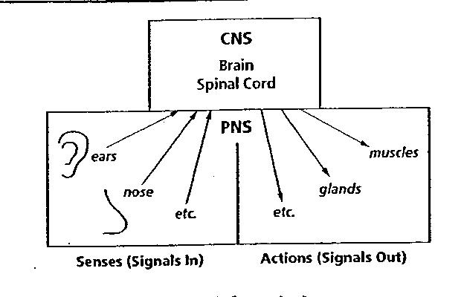

9. How does your central nervous system receive information?

10. Which part of the nervous system do the nerves in your skin belong to?

11. You may not think that caffeine is a drug, but it is. When you drink a soft drink that contains caffeine, you may feel jittery. Why do you think this is so?

Cross Section of Spinal Cord
12. Label the following parts of a spinal cord on the cross-section diagram.
a. white matter
b. grey matter
c. dorsal root ganglion
d. nerve fibers
e. interneuron
f. synapse
g. sensory neuron
h. motor neuron

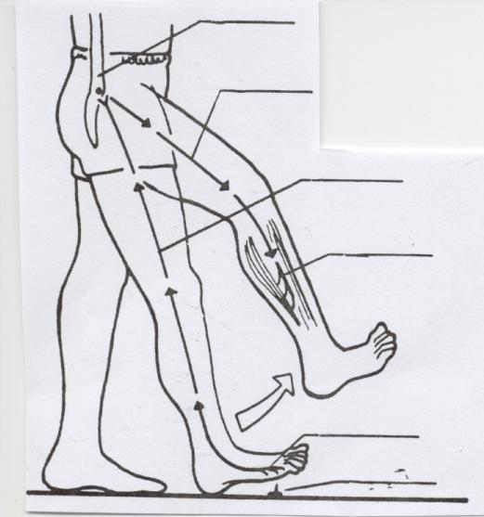 |  | Reflex Act  Label the following parts of a reflex  act on the diagram of a boy stepping  on a tack and jerking his leg away.  a. sensory neuron  b. motor neuron  c. stimulus  d. spinal cord  e. receptor (in skin)  f. effector (muscle)

Fill in the blanks with the correct answers.

13. Suppose you stepped on a tack. You jerked your leg away _____________ you were aware of what
happened. The impulse traveled from the _________________, the skin, along a(an) _____________ neuron into
the ________________. The impulse jumped across a(an) _____________ to a(an) ________________________; then
across another synapse to a ___________ neuron. The impulse traveled along this nerve to a
muscle _________________, in your leg. You jerked your leg away. Only a fraction of a second later,
a(an) _________________ traveled up your brain. But you had _____________ reacted. This kind of reaction is
known as a(an) ________________________________. Reflex acts occur without thinking.

